DATA FLOW DIAGRAM TEMPLATE

Online Ride Sharing

Prepared by Abdul Rehman Aamir

Bcs163001

Capital University of Science and Technology

May 4th, 2018

**REVISION HISTORY**

|  |  |  |
| --- | --- | --- |
| **Date** | **Description** | **Author** |
| 4/5/2018 | Online Ride Sharing | Abdul Rehman Aamir |

Contents

**1 Introduction** 4

**1.1** **About Project:** 4

**1.2** **Purpose:** 4

**1.3** **Scope:** 4

**1.4** **Modules:** 4

**1.5 Conclusion** 4

**2** **Steps for Data Flow Diagram** 5

**2.1** **Listing all Use Cases** 5

**2.2** **Selecting Use Case** 5

**2.3** **Assigning Name to Use Case** 5

**2.4** **Sub-categories of Selected Use Case** 5

**2.5 Defining Conditions According to Situation** 5

2.5 Identifying Entities 5

2.6 Identifying Data Flow 5

2.7 Identifying data store 6

2.8 Identify Data 6

3.0 Context Level Diagram 6

3.1 Level 0 Diagram 7

3.2 Level 1 Diagram 8

# **1 Introduction**

## **About Project:**

The aim of this project is to design an application for the cust bus system so that students can easily get registered online. Admin can track every bus related to cust bus system and students can take multiple actions against bus. It would be easy for admin, driver and the student to coordinate.

## **Purpose:**

A **Data Flow Diagram** is an excellent tool to understand the flow of the data. Through DFD we can identify the entities, stores etc.

## **Scope:**

The scope for the system can be as follows:

* Online registration of students
* Keep a track on buses.
* Feature to cancel ride anytime

## **Modules:**

The main users in the project can be categorized into three modules.

* Admin
* Driver
* Student

## **1.5 Conclusion**

After Studying the whole feasibility report it is concluded that this application is useful and economical and will provide a good usability to the user.

# **Steps for Data Flow Diagram**

## **Listing all Use Cases**

* Admin Login
* Student Login
* Driver Login
* Student Signup
* Driver Signup
* Admin Signup
* Generate Pass
* Generate Challan Form
* Student Cancel Ride

### Selecting Use Case

### Admin Login

## Assigning Name to Use Case

### Login Admin.

## Main Steps:

1. Enter User Name and Verify User Name
2. Enter Password and Verify Password
3. Enter Captcha and Verify Captcha

## Defining Conditions According to Situation

1. Admin have to enter username correctly otherwise an error message will occur
2. Admin have to enter password correctly otherwise an error message will occur
3. Admin have to enter captcha correctly otherwise an error message will occur
4. If he entered all the fields correctly then show the next page.

## 3.3 Identifying Entities

* Admin

## Identifying Data Flow

* Admin to login account
* Login account to data base

## 3.5 Identifying data store

* Database

## Identify Data

* Admin Information

# Context Level Diagram:

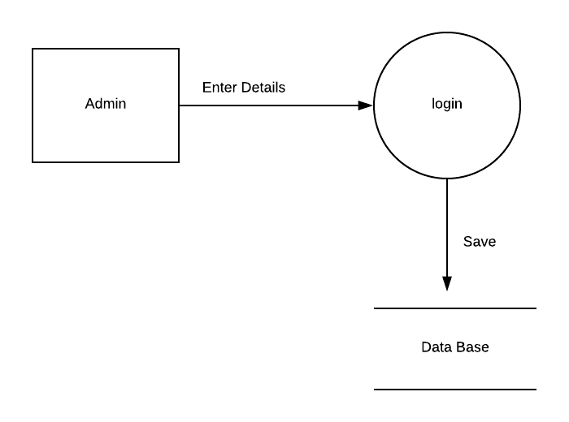

## Level 0 Diagram:

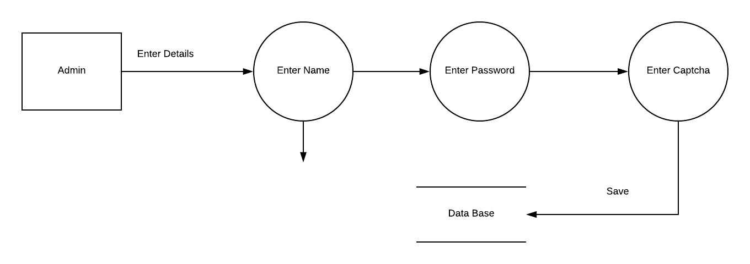

## Level 1 Diagram

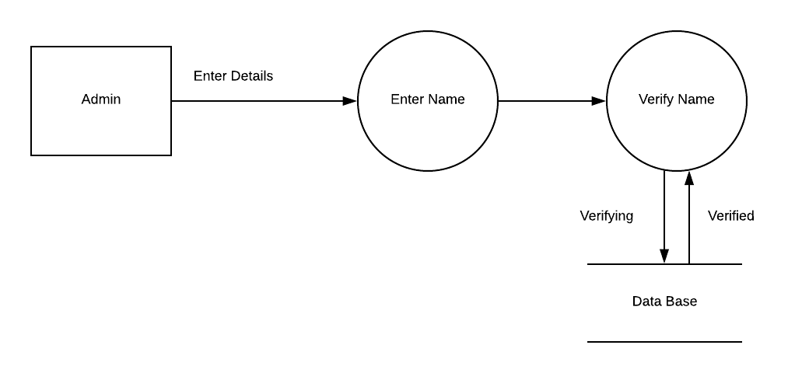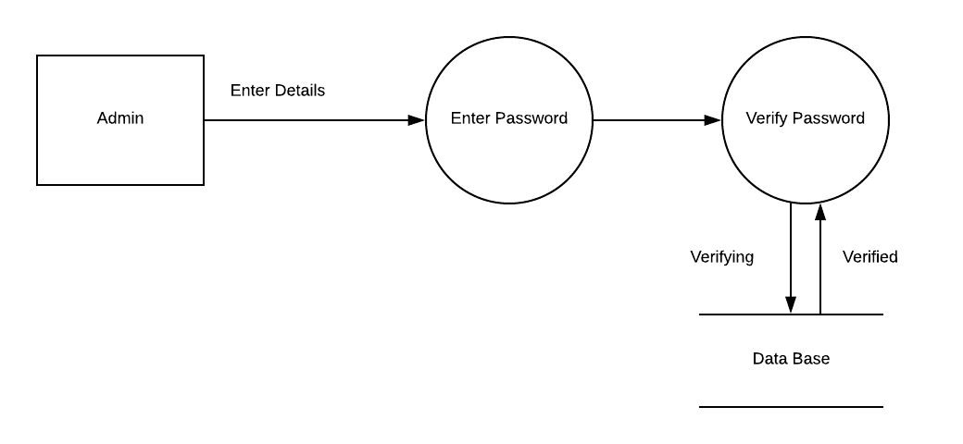

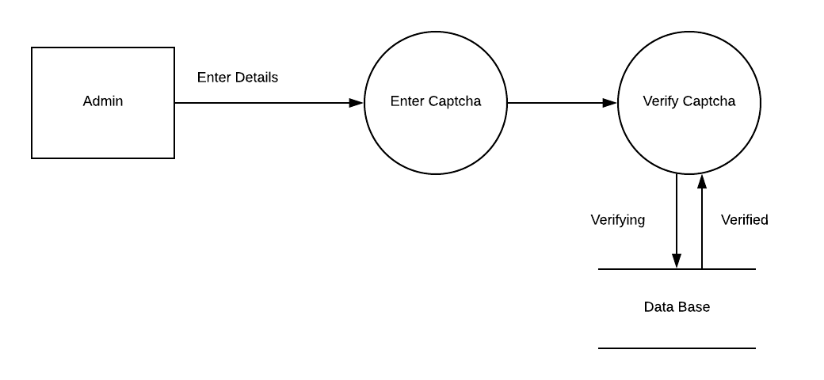

### Selecting Use Case

### Student Can Generate Challan

## Assigning Name to Use Case

### Generating challan

## Main Steps:

1. Login to the Account
2. Ask for challan

## Defining Conditions According to Situation

1. Student have to login to the valid account
2. Student have to ask for challan
3. Product will verify the details and prints it

## Identifying Entities

## Student

## Identifying Data Flow

## Login account to data base

## Identifying data store

## Database

## Identify Data

## Student Information

## Context Level Diagram

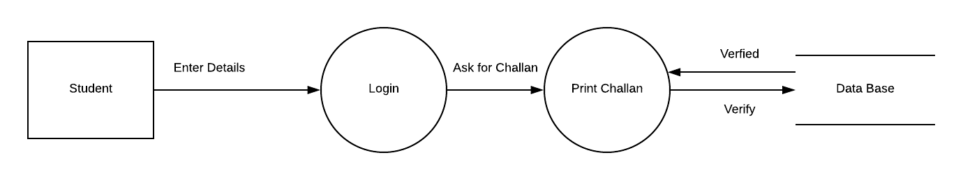

## Level 0 Diagram

## 

## Level 1 Diagram

## 

### Selecting Use Case

### Student Can Generate Pass

## Assigning Name to Use Case

### Generating Pass

## Main Steps:

1. Login to the Account
2. Enter the valid number of paid challan form
3. Ask for pass

## Defining Conditions According to Situation

1. have to enter username correctly otherwise an error message will occur
2. Admin have to enter password correctly otherwise an error message will occur
3. Admin have to enter captcha correctly otherwise an error message will occur
4. If he entered all the fields correctly then show the next page.

## Identifying Entities

## Admin

## Identifying Data Flow

## Admin to login account

## Identifying Data Flow

## Login account to data base

## Identifying data store

## Database

## Identify Data

## Admin Information

## Level 0 Diagram

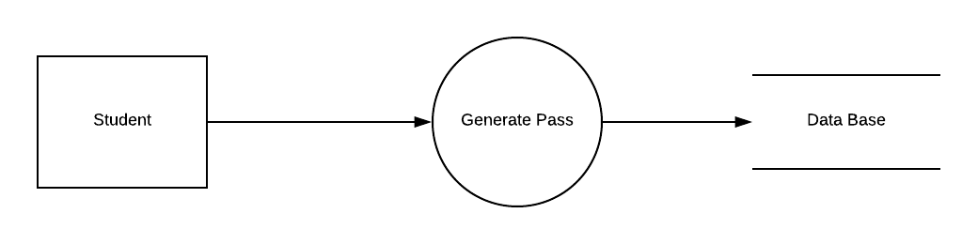

## Level 0 Diagram

## 

## Level 1 Diagram

## 

## Level 1 Diagram

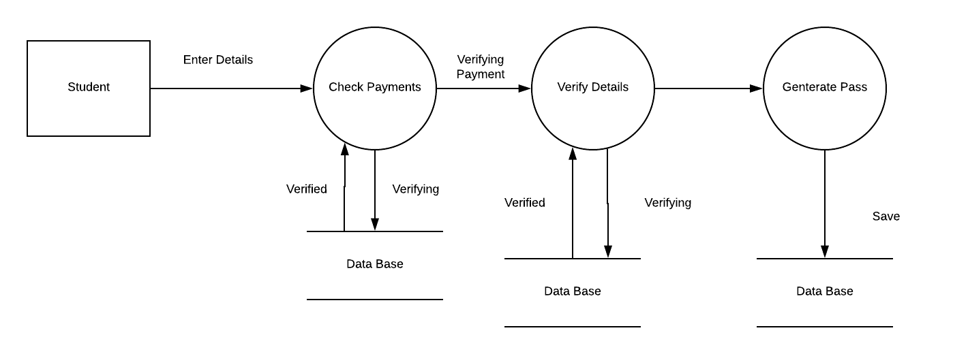

### Selecting Use Case

### Student Can login

## Assigning Name to Use Case

### Login student

## Main Steps:

1. Enter User Name and Verify User Name
2. Enter Password and Verify Password
3. Enter Captcha and Verify Captcha

## Defining Conditions According to Situation

1. Admin have to enter username correctly otherwise an error message will occur
2. Admin have to enter password correctly otherwise an error message will occur
3. Admin have to enter captcha correctly otherwise an error message will occur
4. If he entered all the fields correctly then show the next page.

## Identifying Entities

## Admin

## Identifying Data Flow

## Admin to login account

## Identifying Data Flow

## Login account to data base

## Identifying data store

## Database

## Identify Data

## Admin Information

## Context Level Diagram:

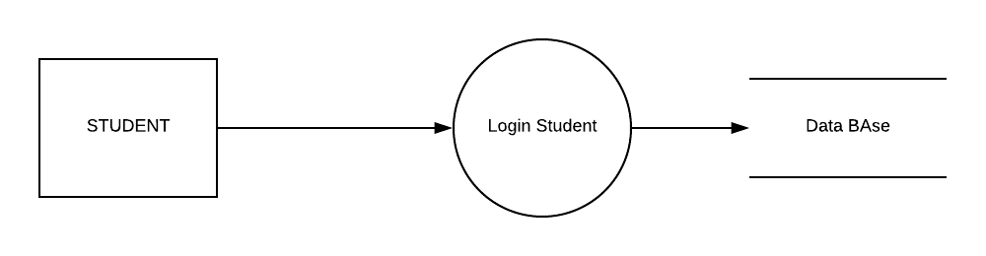

## Level 0 Diagram:

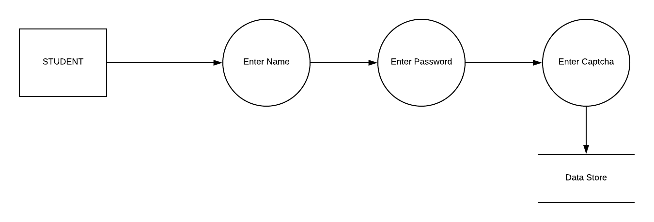

## Level 1 Diagram

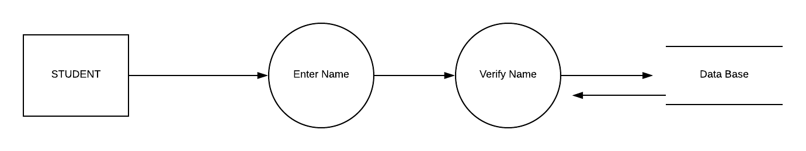

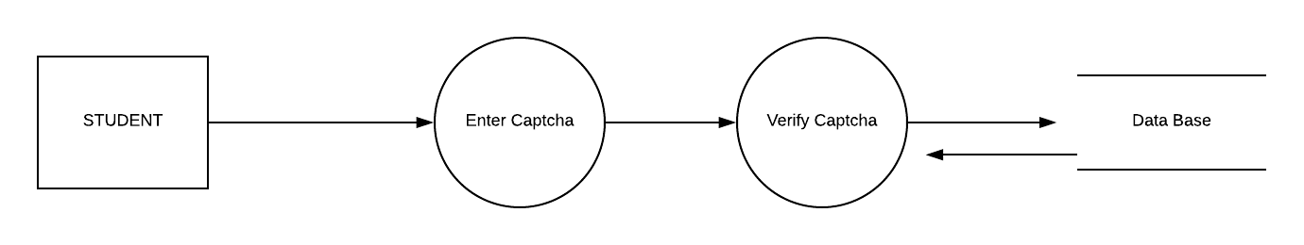

### Selecting Use Case

### Student Can Cancel Rides

## Assigning Name to Use Case

### Cancel Rides

## Main Steps:

1. Enter User Name and Verify User Name
2. Enter Password and Verify Password
3. Enter Captcha and Verify Captcha

## Defining Conditions According to Situation

1. Admin have to enter username correctly otherwise an error message will occur
2. Admin have to enter password correctly otherwise an error message will occur
3. Admin have to enter captcha correctly otherwise an error message will occur
4. If he entered all the fields correctly then show the next page.

## Identifying Entities

## Admin

## Identifying Data Flow

## Admin to login account

## Identifying Data Flow

## Login account to data base

## Identifying data store

## Database

## Identify Data

## Admin Information

## Context Level Diagram:

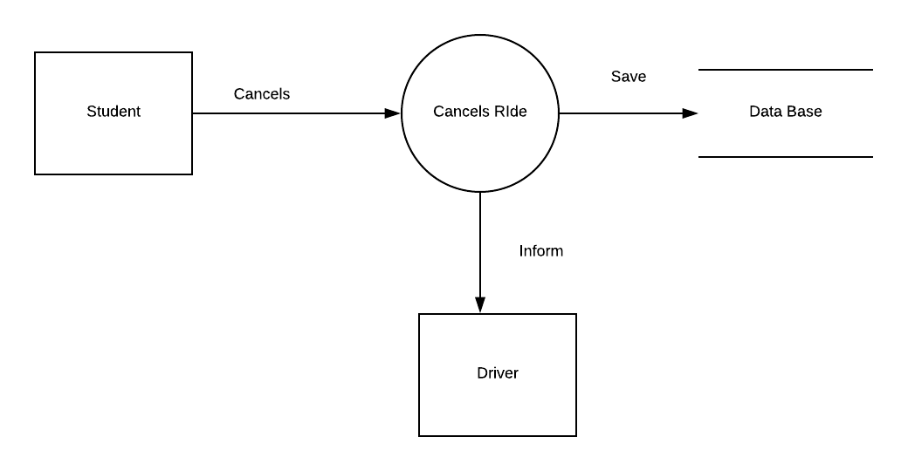

## Level 0 Diagram

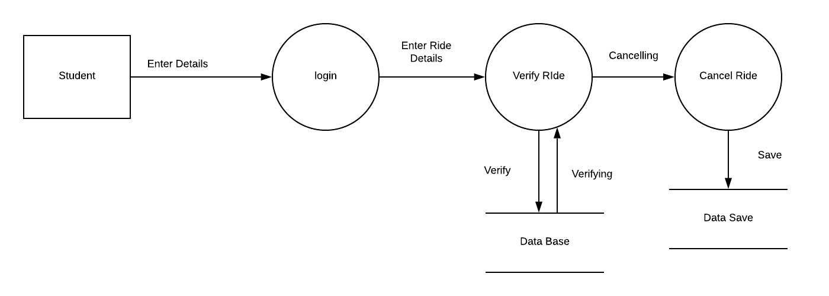

## Level 1 Diagram

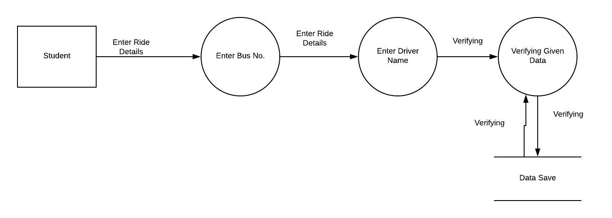

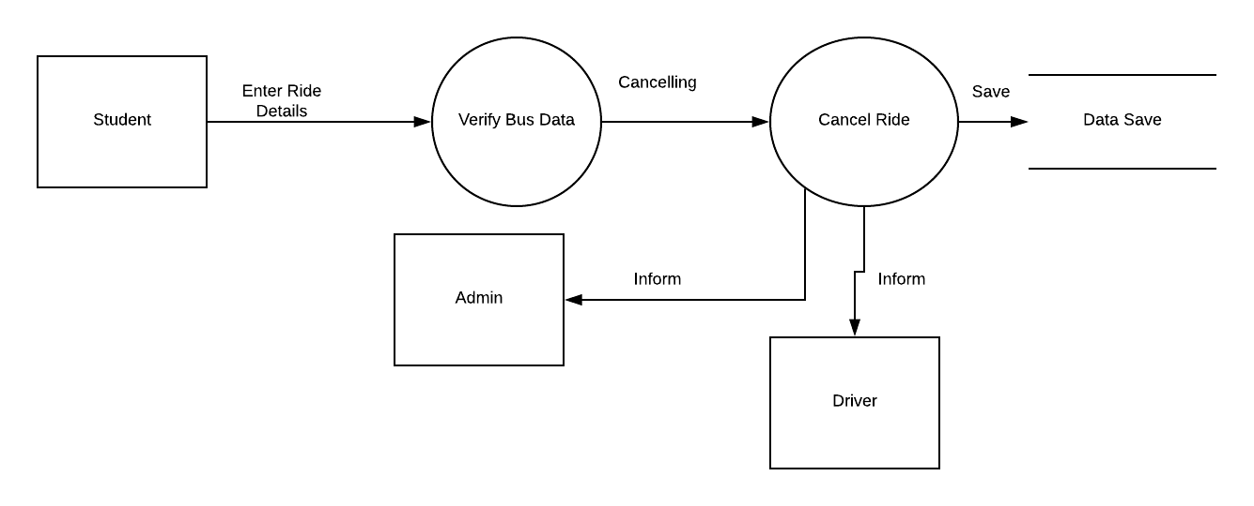

### Selecting Use Case

### Driver Can Signup

## Assigning Name to Use Case

### Signup Driver

## Main Steps:

1. Enter User Name and Verify User Name
2. Enter Password and Verify Password
3. Enter Captcha and Verify Captcha

## Defining Conditions According to Situation

1. Admin have to enter username correctly otherwise an error message will occur
2. Admin have to enter password correctly otherwise an error message will occur
3. Admin have to enter captcha correctly otherwise an error message will occur
4. If he entered all the fields correctly then show the next page.

## Identifying Entities

## Admin

## Identifying Data Flow

## Admin to login account

## Identifying Data Flow

## Login account to data base

## Identifying data store

## Database

## Identify Data

## Admin Information

## Context Level Diagram

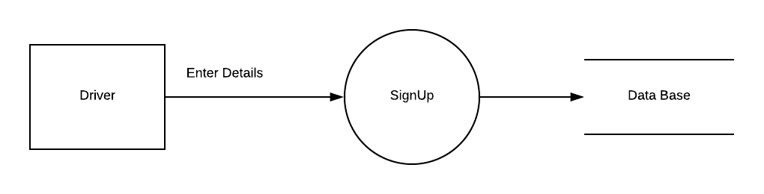

## Level 0 Diagram

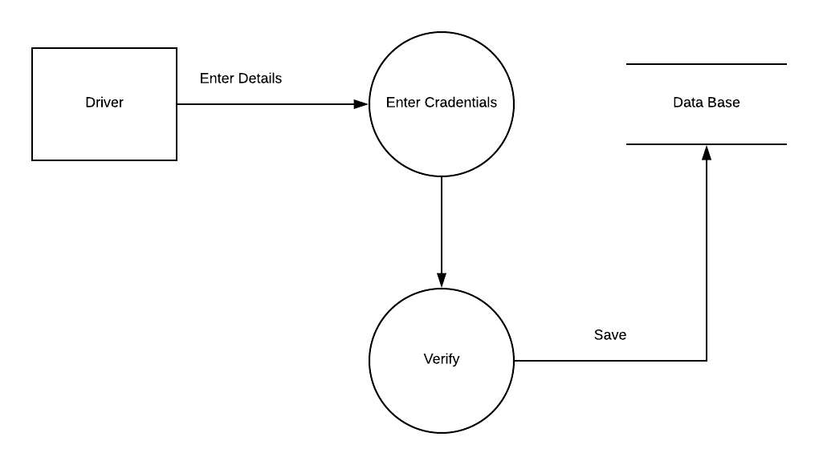

## Level 1 Diagram

